Baseball Umpire Analysis

Umpire Strike Zone Report for Joe West

# Overall Strike Zone

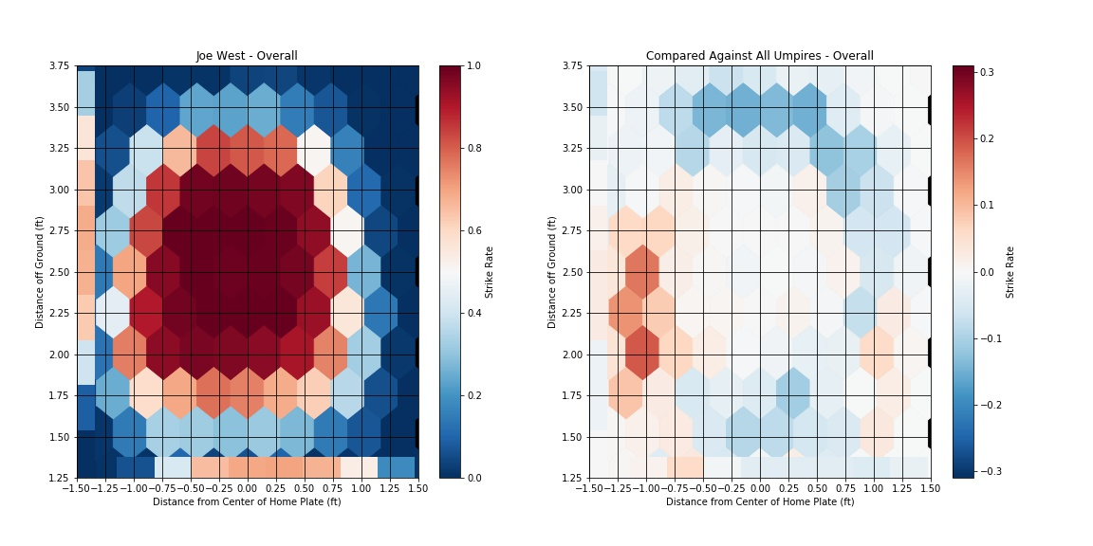

# Strike Zone Left handed Batters

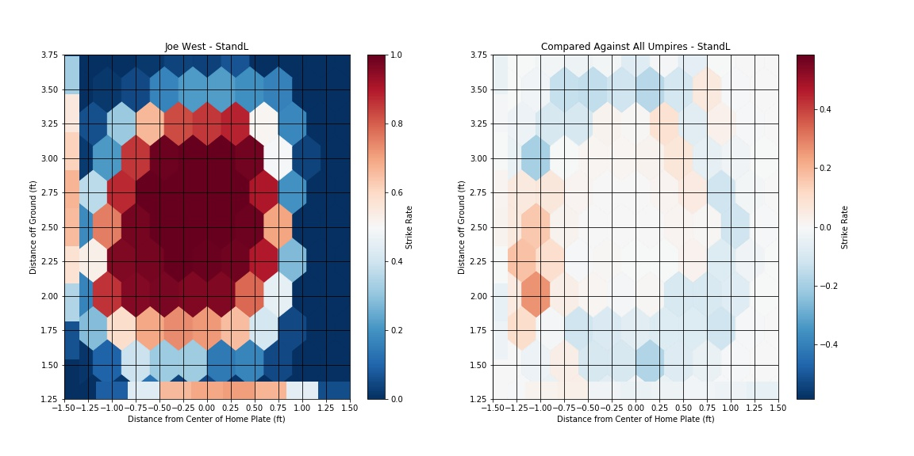

# Strike Zone Right handed Batters

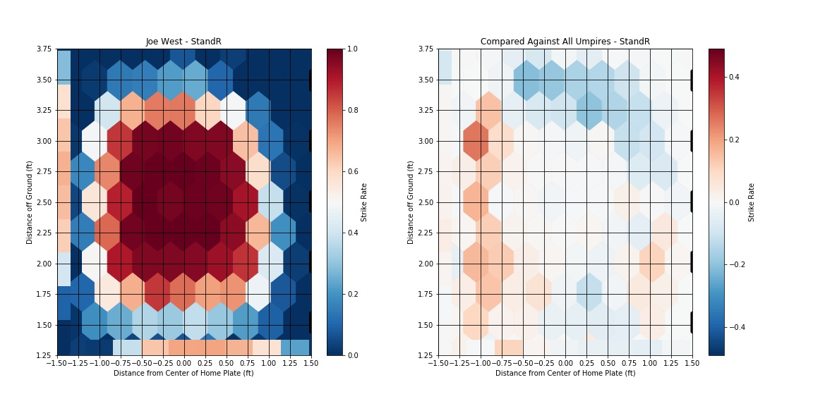

# Strike Zone Left handed Pitchers

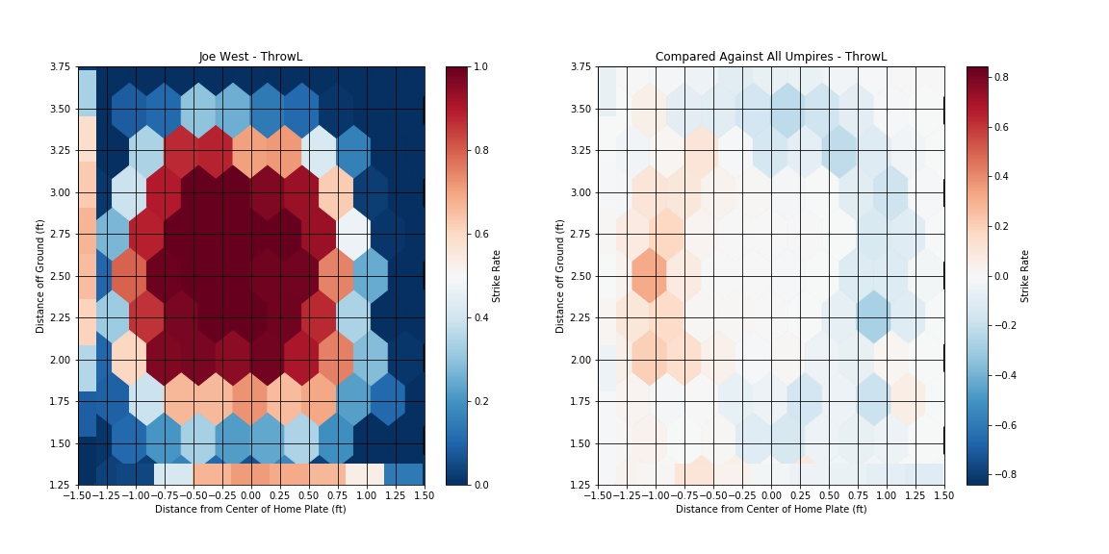

# Strike Zone Right handed Pitchers

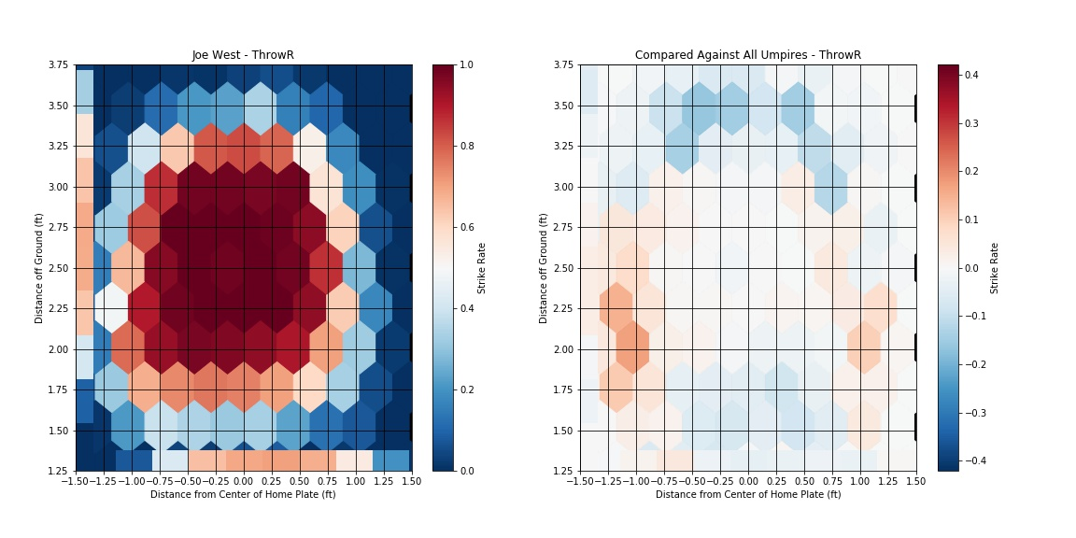

# Strike Zone at the Begining of the game (<=2 innings)

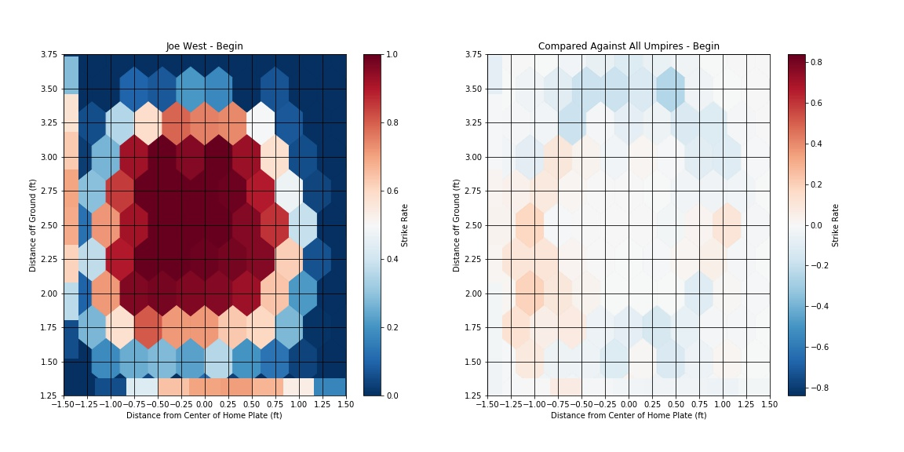

# Strike Zone at the End of the game (>=8 innings)

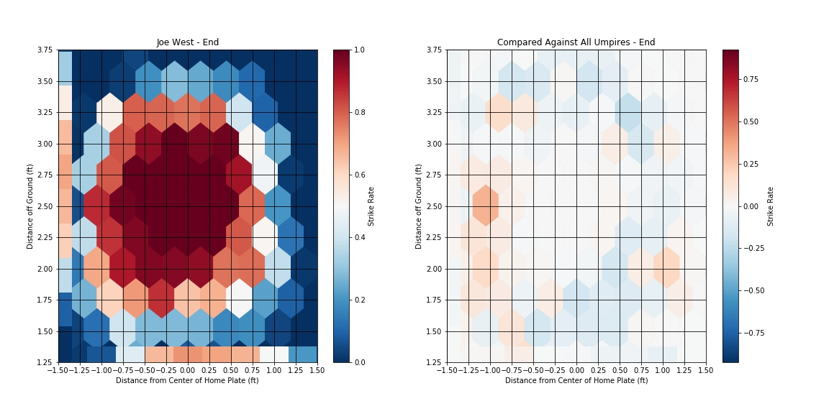

# Strike Zone for shorter batters (less than 5'10)

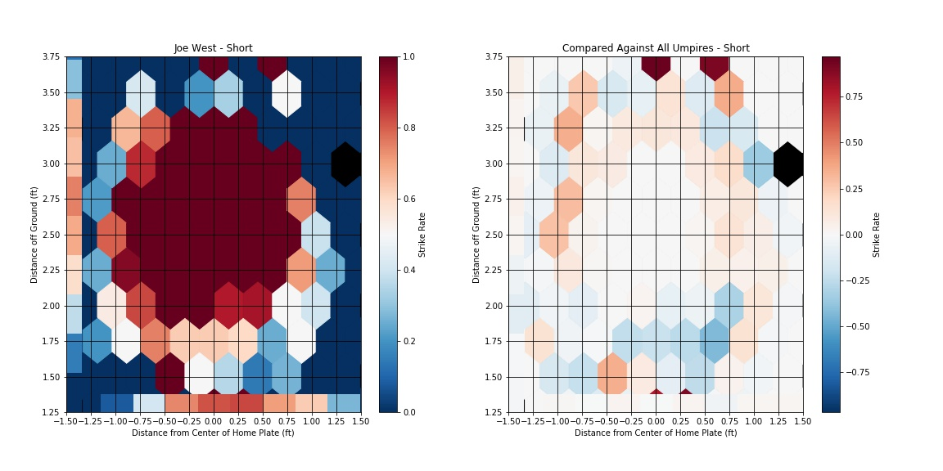

# Strike Zone for Taller batters (greater than 6'2)

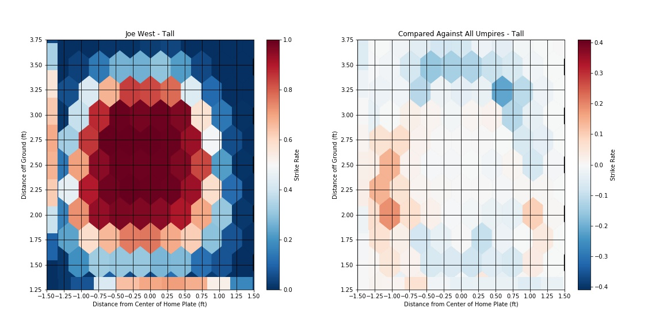

# Strike Zone for games happening during day time

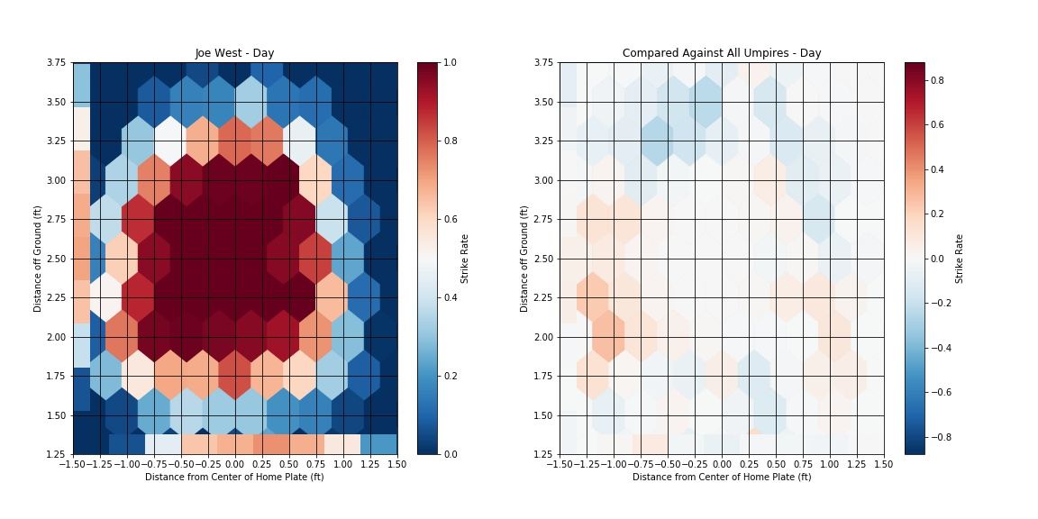

# Strike Zone for games happening during Night time

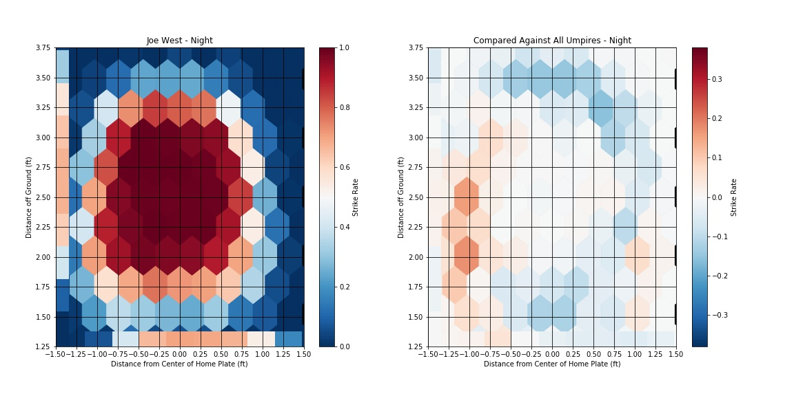

# Strike Zone for games that are tight (diff in score <3)

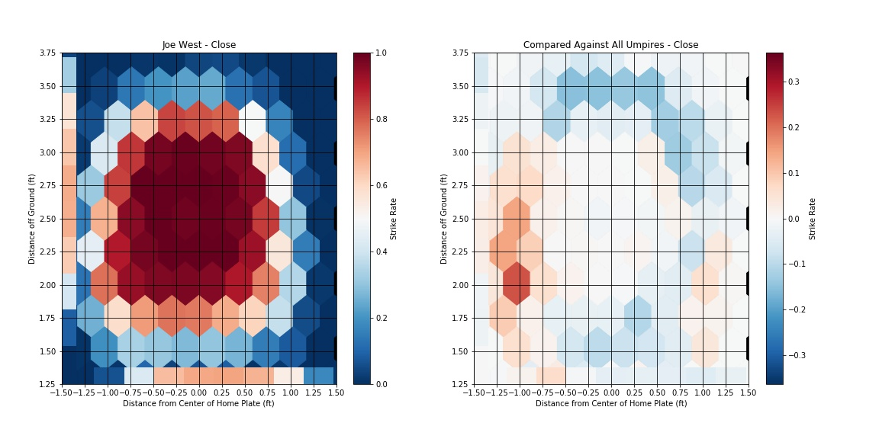

# Strike Zone for games where one team has lead >3

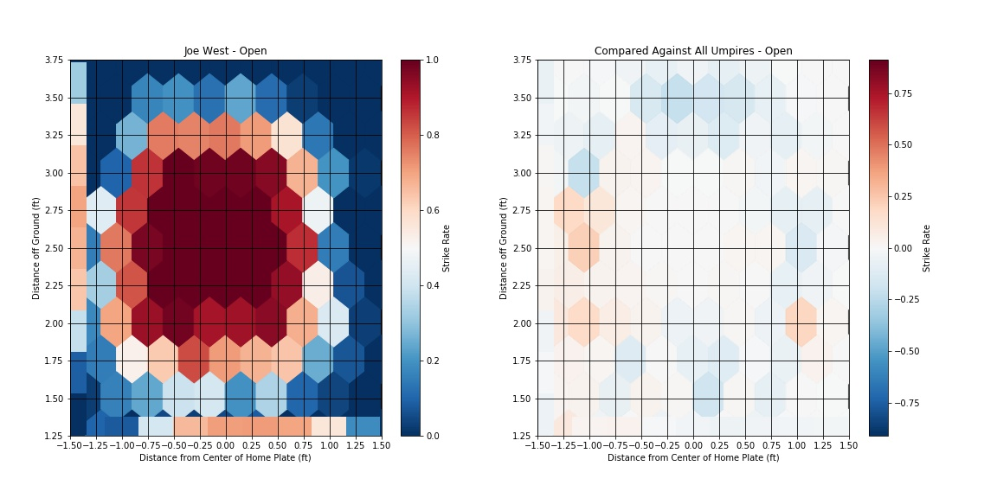

# Strike Zone for regular season games

